EXPERIMENT-5

Name: Mithun Raj D Roll no:240701315

Conduct task analysis for an app and document user flows. Create corresponding wireframes using Lucidchart.

Lucid Chart:
(chatting app Login and Chat Flowchart)
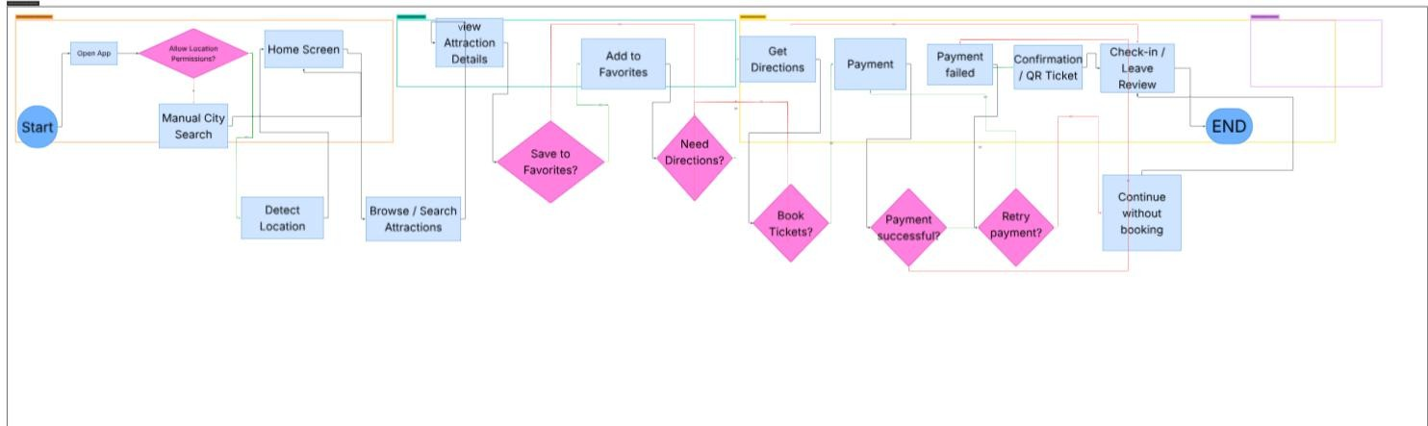

FlowChart Descriptive:
- Start – User opens the travel app.
- Login Check – System checks if the user is logged in.
- Allow Location Permissions? (Decision): A system prompt asking for GPS access.
  - If Yes: The app proceeds to Detect Location automatically.
  - If No: The user is redirected to Manual City Search to input their location.
- Browse/ Search Attractions: The user actively looks for things to do using filters,categories or keyword search bar
- Need Directions? (Decision): Checks if the user needs help navigating to the spot.
- If Yes: Triggers Get Directions (opening an in-app map or external GPS like Google Maps).
- Book Tickets? (Decision): Determines if the user wants to secure a spot or skip the line.
- If Yes: Moves to the Payment gateway to process the transaction.
- If No: The flow bypasses the transaction logic (assuming the user will pay at the gate or it is a free attraction).

- Confirmation / QR Ticket: Upon successful payment, the app generates a digital voucher or QR code for entry.
- Check-in / Leave Review: The final interaction. This occurs either when the user arrives at the venue (Check-in) or after the visit to share their experience (Review).
- End: The completion of this specific user goal.

WireFrame:
Screen 1:

Sign In page for the destination app:
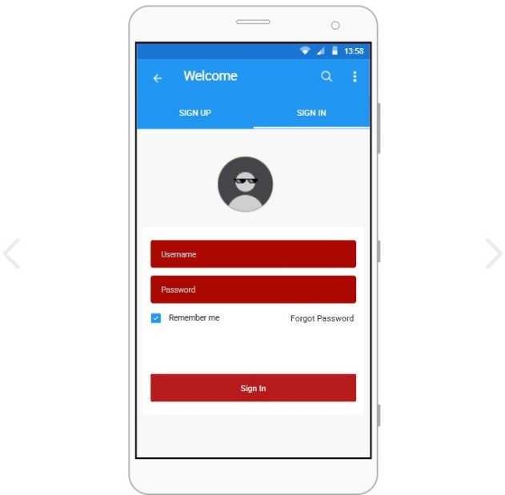

Screen 2:

Home page:

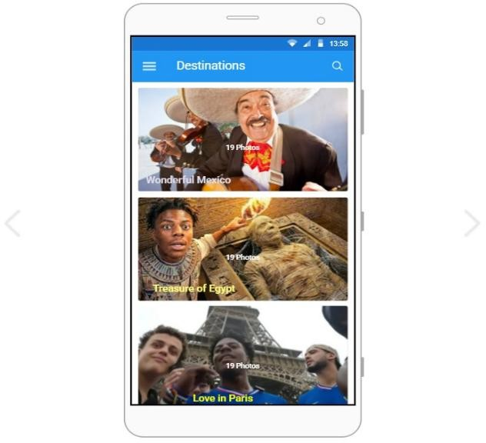

Screen3:

Trip booking screen:

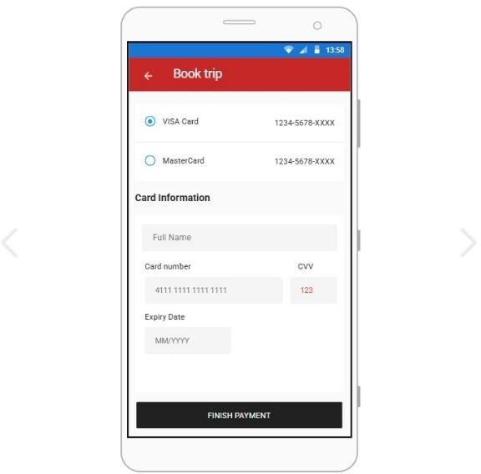

Lucid chart prototype link : https://lucid.app/lucidchart/b3aa6427-8627-4fd5- 9a9a-58428d21b5f2/edit?viewport_loc=-4499%2C- 16565%2C11898%2C4690%2C0_0CinvitationId=inv_175f04b9-662d-44b3-849f-
463fd88b7716

